

**Center for Latino/a and Latin American Studies**

**Summer Enrichment Program**

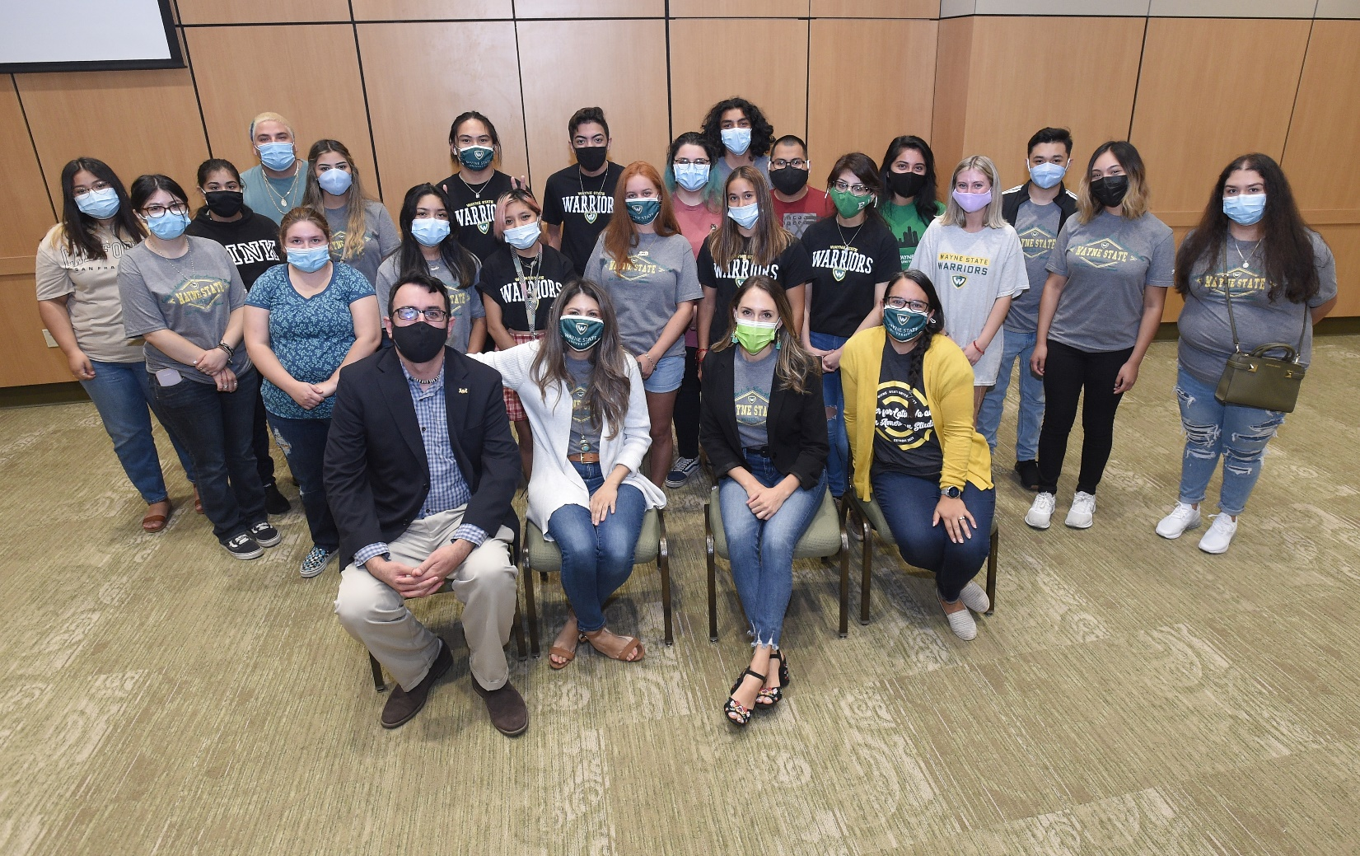

**Details**

**Dates:** Tuesdays/Thursdays

June 23 – August 14, 2020

**Cost:** Free for students who qualify

**Program components**

* Communication and English credited courses
* Math workshop
* Cultural studies workshops
* Free lunch
* Free parking
* Course materials
* Program t-shirt
* Peer mentor and advisor support

The 2022 Summer Enrichment Program through the Center for Latino/a and Latin American Studies is designed to give incoming first-year students a head start on their journey at Wayne State University. As an SEP student, you will earn credits on your WSU transcript at no cost to you. Additionally, the math and cultural studies workshops will help prepare you for the upcoming fall semester. [Many students are able to place at a higher course level after completing the program.] We are confident you will find SEP to be a valuable investment of your time this summer.

Sponsored by:

For more information, contact our advisor:

**Estenia Elisevich, Academic Advisor I**

Center for Latino/a and Latin American Studies

[hb9929@wayne.edu](mailto:hb9929@wayne.edu)

las.wayne.edu